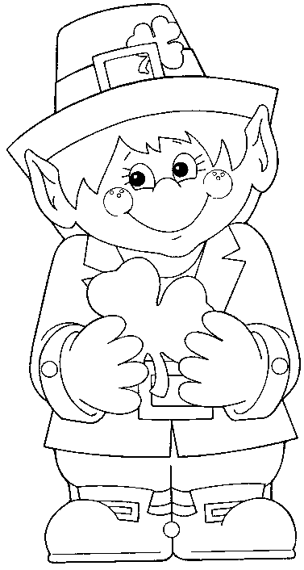
Here’s a wee present for you

Full of luck and wishes

Celebrate this St. Patrick’s Day

With these Leprechaun Kisses!

Here’s a wee present for you

Full of luck and wishes

Celebrate this St. Patrick’s Day

With these Leprechaun Kisses!

Here’s a wee present for you

Full of luck and wishes

Celebrate this St. Patrick’s Day

With these Leprechaun Kisses!

Here’s a wee present for you

Full of luck and wishes

Celebrate this St. Patrick’s Day

With these Leprechaun Kisses!

I’m LUCKY to be your neighbor!
Happy St. Patrick’s Day!

Made with Love by:

________________________________

I’m LUCKY to be your neighbor!
Happy St. Patrick’s Day!

Made with Love by:

________________________________

I’m LUCKY to be your neighbor!
Happy St. Patrick’s Day!

Made with Love by:

________________________________

I’m LUCKY to be your neighbor!
Happy St. Patrick’s Day!

Made with Love by:

________________________________

